Algebra 1: Unit 5, Lesson 2

- Jada incorrectly solved the equation, $5.24x+4.14=-13.86+4.74x$, as shown in the table.
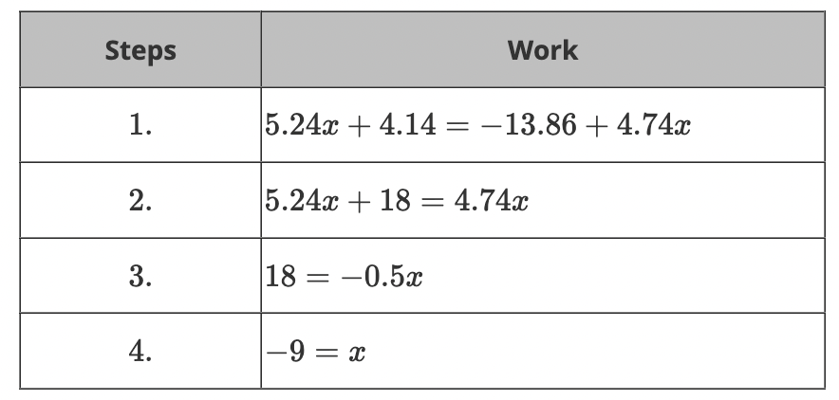
Which step shows Jada’s first mistake?
Step 4

- An equation is shown.
$$-19g+32=-4-24g$$
What is the value of $g$?
$$\frac{1}{7}$$

- The standard form of a line is shown.
Solve the equation for $x$.
$$\frac{C-By}{A}$$
$$Ax+By=C \\ Ax=C-By$$
$x=$_______________

